**Derivation of the Powercurve for Generic e-Powertrain Specification**

Description

|  |
| --- |
| **Abstract: This document contains a summary of the input and investigations to specify the Powercurve for the e-Powertrain.** |

|  |
| --- |
| The copyright of this document and all supplements remain to ThyssenKrupp Presta AG. It is strictly prohibited to make copy of it and to inform or make accessible to a third party without a written authorization from ThyssenKrupp Presta AG. |

**Revision History**

|  |  |  |  |
| --- | --- | --- | --- |
| **Version** | **Date** | **Modified by** | **Description of the modification** |
| 1.0 | 13.04.2017 | Sebastian Hilger | Document created. |
|  |  |  |  |
|  |  |  |  |

**Distribution**

|  |  |  |  |
| --- | --- | --- | --- |
| **Name** | **Department** | **Name** | **Department** |
| Generic e-Powertrain Specification | CC E-Mobility | Katja Stengert | CC E-Mobility |
| Philipp Matt | CC E-Mobility | Martin Stöck | CC E-Mobility |

**References**

|  |  |  |
| --- | --- | --- |
| **No.** | **Authors** | **Title** |
|  |  |  |
|  |  |  |
|  |  |  |
|  |  |  |
|  |  |  |
|  |  |  |
|  |  |  |
|  |  |  |
|  |  |  |
|  |  |  |
|  |  |  |
|  |  |  |
|  |  |  |
|  |  |  |
|  |  |  |
|  |  |  |
|  |  |  |

**List of symbols and abbreviations**

|  |  |
| --- | --- |
| **Symbol / Abbreviation** | **Description** |
|  |  |
|  |  |
|  |  |
|  |  |
|  |  |
|  |  |

**Table of Contents**

1. Introduction 6

1.1. Goal for Specification 6

1.2. Summary vehicle data 6

2. General Remark 8

3. Vehicle CW 8

4. Vehicle Acceleration 10

5. Vehicle Weight 11

6. Gearbox Inertia 15

7. Wheel inertia 18

8. Max Motor Speed 19

8.1. Definition 19

8.2. Assumptions 20

8.3. Tire Diameter Forecast 20

8.4. Summary 21

9. Peak Power 22

9.1. Acceleration 0km/h to 100 km/h 22

9.2. Acceleration 0km/h to 200 km/h 23

9.3. Baldwin Street in New Zealand (40km/h, 35% slope) 23

9.4. Power decrease at high speed 23

9.4.1. Turbocharged engine 23

9.4.2. induction engine 24

9.4.3. BMW i3 24

9.4.4. Chevrolet Bolt 25

9.4.5. Chevrolet Spark EV 26

9.4.6. Renault Zoe 27

9.4.7. Tesla Model S 27

9.4.8. Summary 29

10. Continuous Power 30

10.1. Mountain Pass (80km/h, 12% slope) 30

10.2. San Bernadino (80km/h, 12% slope) 30

10.3. Kasseler Mountains (100km/h, 8% slope) 31

10.4. Highway (140km/h, 4% slope) 32

10.5. Maximum speed (defined by segment, 0% slope) 32

11. Derived Specification 32

**List of Figures**

Figure 1: motor curve 6

Figure 3: extract of official EU commission document 11

Figure 4: extract of US EPA vehicle definition 11

Figure 6: tire model 18

Figure 7: tire data 18

Figure 8: wheel model 19

Figure 9: wheel data 19

Figure 10: rim size vs. vehicle class 21

Figure 11: gear ratio compared to max vehicle speed (lower gear ratio = higher vehicle speed) HP = high performance 21

Figure 12: possible vehicle speed with gear ratio different gear ratios, Sport = 230km/h HP = high performance 250km/h 22

Figure 14: Power Curve induction engine 24

Figure 15: BMW i3 torque curve 25

Figure 16: Chevrolet Bolt torque curve 25

Figure 17: Chevrolet Spark axle torque 26

Figure 18: Renault Zoe power curve 27

Figure 19: power curve Tesla Model S 28

Figure 20: motor curve derivation 29

Figure 21: power curve derivation 30

**List of Tables**

Table 1: vehicle data [weight and size] 6

Table 2: vehicle data [speed and motor] – considered are BEV and ICE engines 7

Table 3: market trend for BEV vehicle on tire data 7

Table 4: acceleration values of sport cars 11

Table 4: compared vehicle weight ICE and BEV 14

Table 5: motor revolution at 200km/h 29

# Introduction

This documentation shall sum up all investigations analysis and assumptions taken into account to specify the first generic powercurve requirement for the e-Powertrain.

## Goal for Specification

During this document the powercurve and the breakdown from vehicle shall be described. Three major points give us an indication of the powercurve.

Figure 1: motor curve

## Summary vehicle data

Here the assumed vehicle data for later calculation is noted. The assumptions and the sources are listed in the following chapters per topic.

|  |  |  |  |  |  |
| --- | --- | --- | --- | --- | --- |
| **Vehicle segment** | **Min vehicle weight [kg]** | **Payload [kg]** | **cw** | **Frontal area**  **[m x m]** | **Frontal area based on** |
| A | 1110 | 350 | 0.27 | 1.65 x 1.6 | Chevrolet Spark |
| B | 1330 | 425 | 0.27 | 1.75 x1.5 | BMW i3 |
| C | 1585 | 500 | 0.27 | 1.8 x 1.5 | VW e-Golf, Chevrolet Bolt, VW I.D. |
| D | 1740 | 625 | 0.24 | 1.9 x 1.5 | BMW 5er |
| E | 2100 | 650 | 0.24 | 1.95 x 1.5 | Tesla Model S |
| F | 2200 | 650 | 0.24 | 1.95 x 1.5 | BMW 7er |
| M | 2065 | 900 | 0.3 | 1.95 x 1.95 | VW I.D. Buzz |
| J Low | 1800 | 650 | 0.24 | 1.95 x 1.5 | Audi Q5 |
| J High | 2300 | 650 | 0.24 | 1.95 x 1.5 | Audi Q6 e-tron, Q7 |
| S | 1900 | 400 | 0.24 | 2.0 x 1.3 | Porsche Mission e |

Table 1: vehicle data [weight and size]

|  |  |  |  |  |  |
| --- | --- | --- | --- | --- | --- |
| **Vehicle segment** | **Max vehicle speed [km/h]** | **0 to 100 km/h**  **[s]** | **0 to 200 km/h**  **[s]** | **Number of motors** | **Frontal area based on** |
| A | 160 | 7 |  | 1 | Chevrolet Spark |
| B | 160 | 7 |  | 1 | BMW i3 |
| C | 180 | 6 |  | 1 | VW e-Golf, Chevrolet Bolt, VW I.D. |
| D | 210 / 230 | 5,6 |  | 1 | BMW 5er |
| E | 210 / 230 | 6 |  | 2 | Tesla Model S |
| F | 210 / 230 | 6 |  | 2 | BMW 7er |
| M | 180 | 10 |  | 2 | VW I.D. Buzz |
| J | 210 / 250 | 6 |  | 2 | Audi Q6 e-tron |
| S | 250 | 4 |  | 2 | Porsche Mission e |

Table 2: vehicle data [speed and motor] – considered are BEV and ICE engines

|  |  |  |  |  |
| --- | --- | --- | --- | --- |
| **Vehicle segment** | **Minimal Tire size** | **Tire radius [m]** | **Wheel circumference [m]** | **Wheel inertia**  **[kg*m2]** |
| A | 175/60 R19 | 0.3463 | 2.18 | 1.32059 |
| B | 175/60 R19 | 0.3463 | 2.18 | 1.32059 |
| C | 245/50 R20 | 0.3765 | 2.37 | 2.4622 |
| D | 245/50 R20 | 0.3765 | 2.37 | 2.4622 |
| E | 235/45 R22 | 0.38515 | 2.42 | 3.4052 |
| F | 235/45 R22 | 0.38515 | 2.42 | 3.4052 |
| M | 235/45 R22 | 0.38515 | 2.42 | 3.4052 |
| J | 235/45 R22 | 0.38515 | 2.42 | 3.4052 |
| S | 235/45 R22 | 0.38515 | 2.42 | 3.4052 |

Table 3: market trend for BEV vehicle on tire data

As a boundary the following parameters are defined:

* max motor speed: 20’000rpm
* max peak power 170kW
* continuous power 120kW
* $c_{r}=0.005+(\frac{1}{2}*(0.01+0.0095*{\left(\frac{v_{veh \left[\frac{km}{h}\right]}}{100}\right)}^{2}$, calculated according to Guzella ave

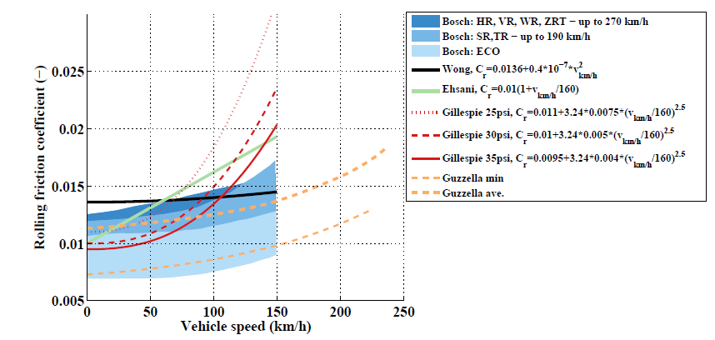

Figure 2: Cr tested and calculated

$ϱ_{a}=1.225\left[\frac{kg}{m^{3}}\right]$

# General Remark

If a value is not remarked somehow within this file, the value is a best guess.

# Vehicle CW

Cw-Wert Sammlung:

<http://rc.opelgt.org/indexcw.php>

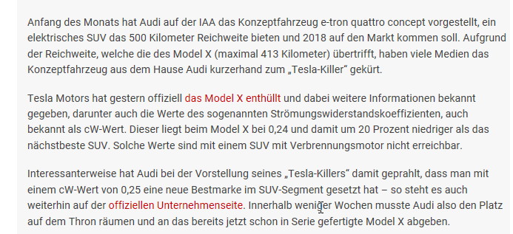

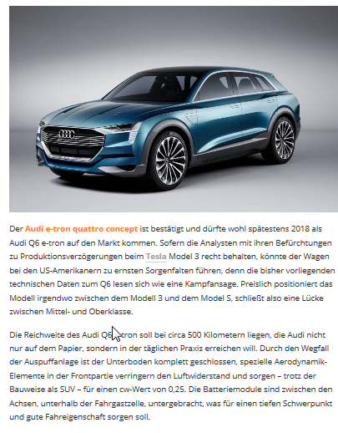

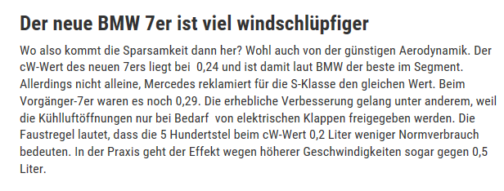

# Vehicle Acceleration

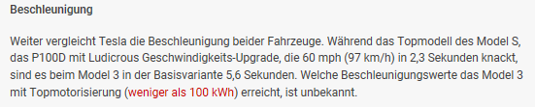

|  |  |  |  |  |
| --- | --- | --- | --- | --- |
| **vehicle** | **0-100** | **0-200** | **vmax** | **segment** |
| [Wiesmann Roadster MF4-S](http://www.autobild.de/marken-modelle/wiesmann/wiesmann-roadster-mf4/1/) | 4.2 | 14.1 | 293 | S |
| [Porsche Boxster Spyder](http://www.autobild.de/marken-modelle/porsche/boxster/981/) | 4.4 | 14.1 | 290 | S |
| [BMW X6 M](http://www.autobild.de/marken-modelle/bmw/x6-m/2/) | 4.1 | 14.1 | 250 | J |
| [Bentley Flying Spur Mulliner](http://www.autobild.de/marken-modelle/bentley/continental-flying-spur/2/) | 4.3 | 14 | 320 | F |
| [Aston Martin Rapide S](http://www.autobild.de/marken-modelle/aston-martin/rapide-s/1/) | 4.5 | 13.9 | 327 | S |
| [Jaguar XFR-S](http://www.autobild.de/marken-modelle/jaguar/xfr-s/1/) | 4.2 | 13.9 | 300 | S |
| [Porsche Cayman GT4](http://www.autobild.de/marken-modelle/porsche/cayman-gt4/1/) | 4.3 | 13.7 | 295 | S |
| [BMW M3](http://www.autobild.de/marken-modelle/bmw/m3/f30/) | 4.3 | 13.7 | 280 | D |
| [Chevrolet Camaro Z/28](http://www.autobild.de/marken-modelle/chevrolet/camaro/fifth-generation/) | 4.4 | 13.5 | 275 | S |
| [Jaguar XJR](http://www.autobild.de/marken-modelle/jaguar/xjr/1/) | 4.1 | 13.4 | 280 |  |
| [Aston Martin Vanquish Coupé](http://www.autobild.de/marken-modelle/aston-martin/vanquish/1/) | 4.1 | 13.3 | 323 | S |
| [Jaguar XKR-S Cabriolet](http://www.autobild.de/marken-modelle/jaguar/jaguar-xkr-s/1/) | 4.3 | 13.3 | 300 | S |
| [Bentley Continental GT Speed](http://www.autobild.de/marken-modelle/bentley/continental-gt/generation-2-2011/) | 4.2 | 13.2 | 330 | S |
| [BMW M4 Coupé](http://www.autobild.de/marken-modelle/bmw/bmw-m4/1/) | 4 | 13.1 | 250 | D |
| [Audi S8](http://www.autobild.de/marken-modelle/audi/s8/d4/) | 4 | 13.1 | 250 | F |
| [Porsche Panamera Turbo](http://www.autobild.de/marken-modelle/porsche/panamera/1/) | 3.7 | 12.9 | 305 | S |
| [Dodge Viper SRT](http://www.autobild.de/marken-modelle/dodge/viper/srt-viper/) | 4 | 12.8 | 332 | S |
| [Jaguar F-Type R Coupé](http://www.autobild.de/marken-modelle/jaguar/f-type/1/) | 4 | 12.8 | 300 | S |
| [Mercedes-AMG C 63 S T](http://www.autobild.de/marken-modelle/mercedes-benz/c-klasse-amg/w205-amg/) | 4.1 | 12.7 | 250 | D |
| [Mercedes-AMG S 63 Coupé](http://www.autobild.de/marken-modelle/mercedes-benz/cl-klasse-amg/c217/) | 3.9 | 12.6 | 300 | F |
| [Aston Martin V12 Vantage S](http://www.autobild.de/marken-modelle/aston-martin/v12-vantage/1/) | 4 | 12.5 | 328 | S |
| [Audi RS6 Avant](http://www.autobild.de/marken-modelle/audi/rs-6/c7/) | 3.6 | 12.4 | 305 | E |
| [Audi RS7](http://www.autobild.de/marken-modelle/audi/rs-7-sportback/1/) | 3.6 | 12 | 250 | E |
| [Mercedes-AMG E 63 S](http://www.autobild.de/marken-modelle/mercedes-benz/e-klasse-amg/w212/) | 3.7 | 11.9 | 300 | E |
| [Dodge Charger SRT Hellcat](http://www.autobild.de/marken-modelle/dodge/charger-srt-hellcat/1/) | 4.2 | 11.8 | 330 | E |
| [BMW M5](http://www.autobild.de/marken-modelle/bmw/m5/f10/) | 4 | 11.8 | 305 | E |
| [Mercedes-AMG SL 63](http://www.autobild.de/marken-modelle/mercedes-benz/sl-klasse-amg/r231/) | 3.9 | 11.7 | 300 | F |
| [Mercedes-AMG CLS 63 S](http://www.autobild.de/marken-modelle/mercedes-benz/cls-klasse-amg/c218/) | 3.6 | 11.7 | 300 | E |
| [Porsche 911 GT3](http://www.autobild.de/marken-modelle/porsche/911-gt3/991/) | 3.4 | 11.2 | 315 | S |
| [Audi R8 5.2 FSI](http://www.autobild.de/marken-modelle/audi/r8/1/) | 3.5 | 11.2 | 317 | S |
| [BMW M6 Coupé Competition](http://www.autobild.de/marken-modelle/bmw/m6/generation-2-2011/) | 3.9 | 11.2 | 305 | E |
| [Mercedes-AMG GT S](http://www.autobild.de/marken-modelle/mercedes-benz/amg-gt/1/) | 3.4 | 11 | 310 | S |
| [Ferrari California T](http://www.autobild.de/marken-modelle/ferrari/california-t/1/) | 3.6 | 11 | 316 | S |
| [Nissan GT-R Black Edition](http://www.autobild.de/marken-modelle/nissan/gt-r/1/) | 3.1 | 10.8 | 315 | S |
| [Dodge Challenger SRT Hellcat](http://www.autobild.de/marken-modelle/dodge/challenger-srt-hellcat/1/) | 3.9 | 10.7 | 320 | E |
| [Mercedes SLS AMG Black Series](http://www.autobild.de/marken-modelle/mercedes-benz/sls-amg/c197/) | 3.6 | 10.6 | 315 | S |
| [Lamborghini Aventador LP700-4 Roadster](http://www.autobild.de/marken-modelle/lamborghini/aventador/1/) | 3 | 9.6 | 350 | S |
| [Porsche 911 Turbo S](http://www.autobild.de/marken-modelle/porsche/911-turbo/991/) | 2.8 | 9.6 | 318 | S |
| [Lamborghini Huracán LP610-4](http://www.autobild.de/marken-modelle/lamborghini/huracan/1/) | 2.9 | 9.3 | 325 | S |
| [McLaren 650S](http://www.autobild.de/marken-modelle/mclaren/650s/1/) | 3 | 8.2 | 333 | S |

Table 4: acceleration values of sport cars

# Vehicle Weight

Data analyses for weight definition:

Commission of the European Communities clearly says that they left open the definition of exact market segments for passenger vehicles.

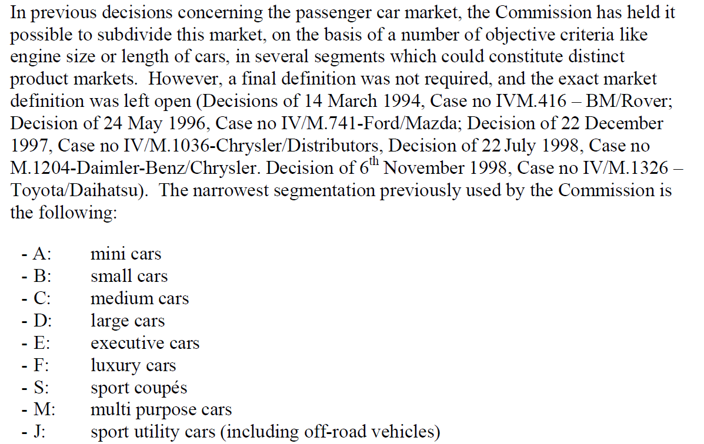

Figure 3: extract of official EU commission document

US EPA:

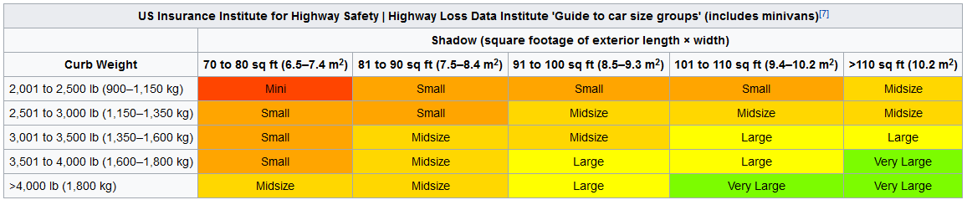

Figure 4: extract of US EPA vehicle definition

EUROPEAN VEHICLE MARKET STATISTICS from ICCT (International Council on Clean Transportation)

Vehicle segments in this document:

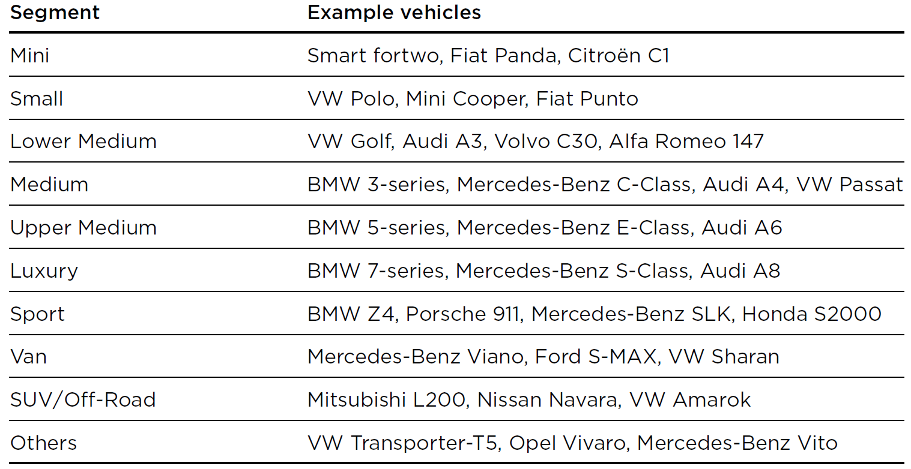

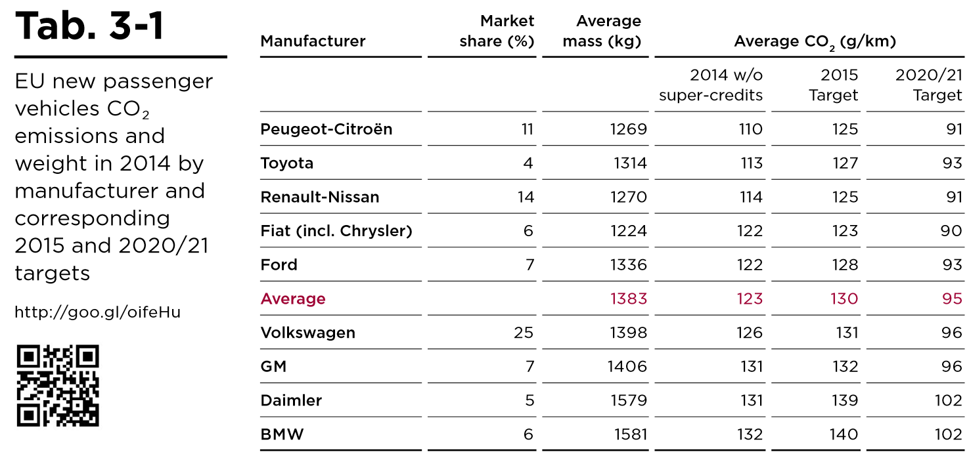

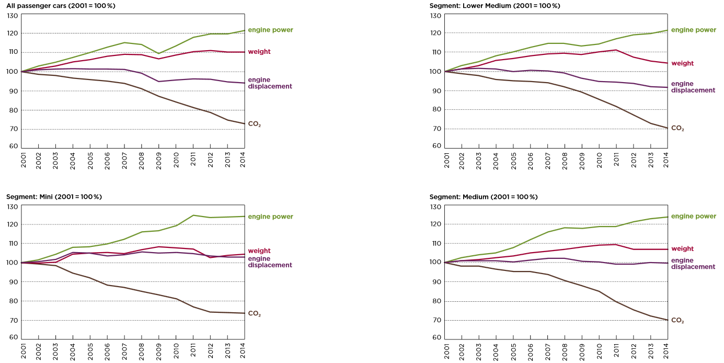

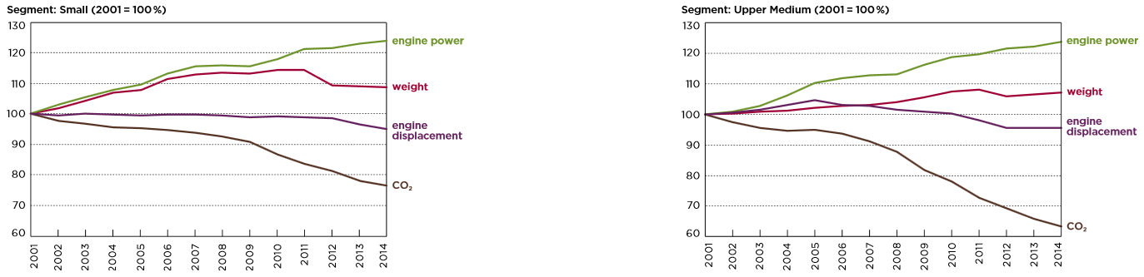

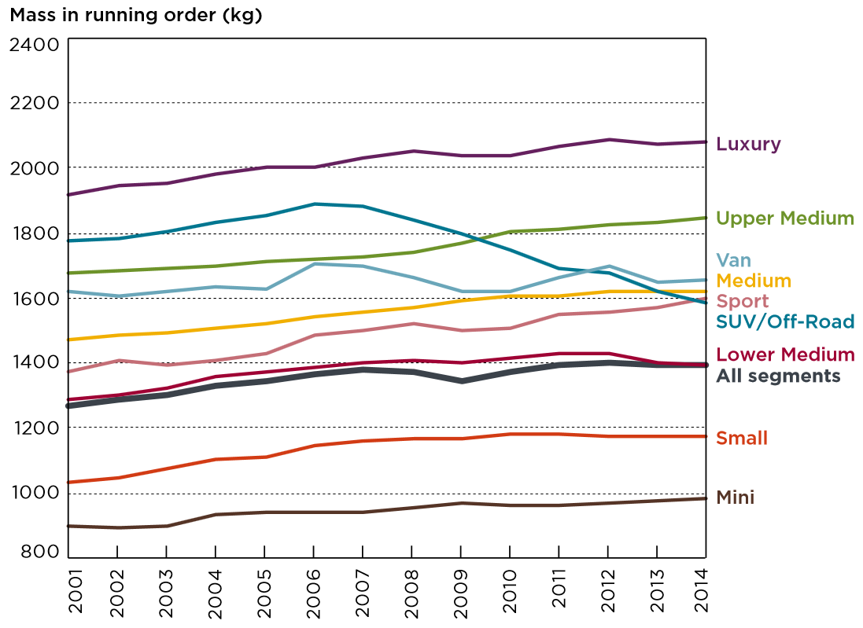

Based on the above graphs the vehicle weight is defined as shown in Table 5. T

|  |  |  |  |  |  |
| --- | --- | --- | --- | --- | --- |
| **Vehicle segment** | **Vehicle Weight**  **[kg]** | **Payload**  **[kg]** | **compared weight EV [kg]** | **delta weight [kg]** | **Not considered capacity increase of battery** |
| A | 980 | 350 | 1110 | 130 | i-miev |
| B | 1170 | 425 | 1330 | 160 | I3 |
| C | 1400 | 500 | 1585 | 185 | e-Golf |
| D | 1640 | 625 | 1740 | 100 | Modell 3 |
| E | 1860 | 650 | 2100 | 240 | Model S (2WD) |
| F | 2060 | 650 | 2200 | 140 | Model S (4WD) |
| M | 1665 | 650 | 2065 | 400 | 400kg |
| J | 1590 | 650 | 2300 | 710 | Model X |
| S | 1610 | 400 | 1900 | 290 | derived from BMW i8 (1560 and optimized model S) |

Table 5: compared vehicle weight ICE and BEV

Cost and well-to-wheel implications of the vehicle fleet CO2 emission regulation in the European Union

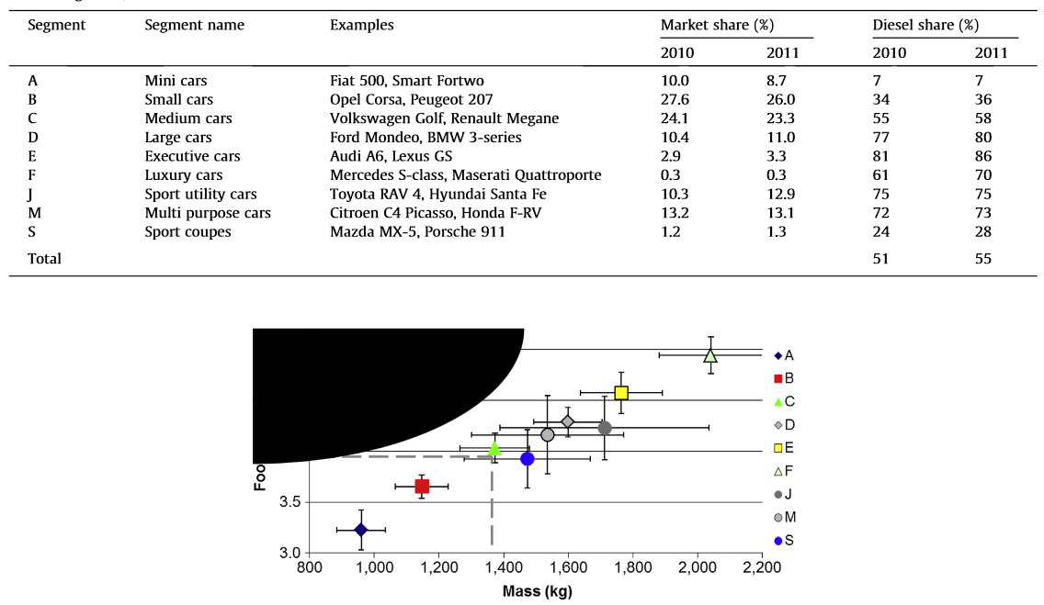

Figure 5: Cost and well-to-wheel implications of the vehicle fleet CO2 emission regulation in the European Union

# Gearbox Inertia

Gearbox inertia can be calculated as an abstract of cylindrical objects (combination of solid and hollow).

**Inertia of solid cylindrical object**

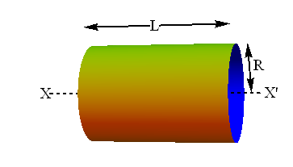

$$I \left[kg*m^{2}\right]=\frac{1}{2}*m \left[kg\right]*r^{2}\left[m\right]= \frac{1}{2}*π*ρ [\frac{kg}{m^{3}}]*l [m]*r^{4}[m]$$

I: Inertia

m: vehicle mass

r: radius

ρ: density of the material

l: length

**Inertia of hollow cylindrical object**

$$I \left[kg*m^{2}\right]=\frac{1}{2}*m \left[kg\right]*(r_{o}^{2}\left[m\right]-r_{i}^{2}\left[m\right])= \frac{1}{2}*π*ρ [\frac{kg}{m^{3}}]*l [m]*(r_{o}^{4}\left[m\right]-r_{i}^{4}\left[m\right])$$

I: Inertia

m: vehicle mass

r: radius

ρ: density of the material

l: length

**Gear driven Inertia**

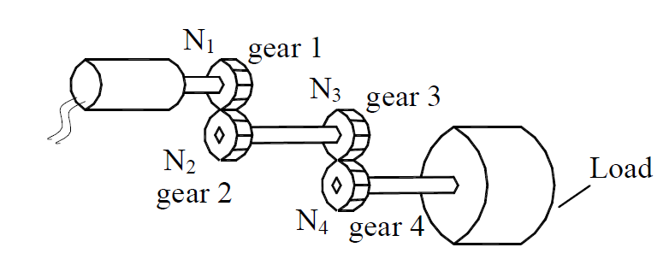

$$I_{total}\left[kg*m^{2}\right]=I_{motor}+I_{gear 1}+{(\frac{N_{1}}{N_{2}})}^{2}*\{I_{gear 2}+I_{gear 3}+{\left(\frac{N_{3}}{N_{4}}\right)}^{2}*\left(I_{gear 4}+I_{load}\right)\}$$

I: Inertia

N: number of gear teeth on gear

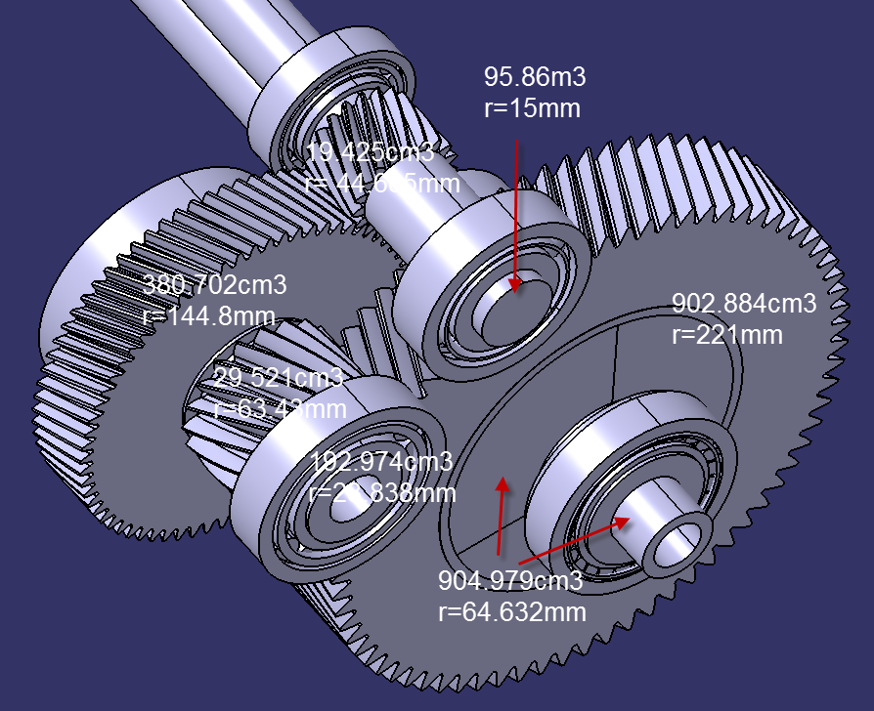

|  |  |  |  |  |  |  |  |  |  |
| --- | --- | --- | --- | --- | --- | --- | --- | --- | --- |
|  |  | **Shaft 1** | **Gear 1** | **Gear 2** | **Shaft 2** | **Gear 3** | **Gear 4** | **half-shaft** | **Differential** |
| V [m3] | 3D model | 0.00009586 | 0.000019425 | 0.000380702 | 0.000192974 | 0.000029521 | 0.000902884 | 0.01 |  |
| rinner [m] | 3D model |  | 0.016882 | 0.028838 |  | 0.023316 | 0.064632 | 0.015 |  |
| router [m] | 3D model | 0.015 | 0.044665 | 0.1448 | 0.028838 | 0.06343 | 0.221 | 0.499891 |  |
| l [m] | 3D model | - | - | - | - | - | - | 0.000196307 |  |
| ρ [kg/m3] | specification | 7800 | 7800 | 7800 | 7800 | 7800 | 7800 | 7800 | 7800 |
| m [kg] | calculated | 0.747708 | 0.151515 | 2.9694756 | 1.5051972 | 0.2302638 | 7.0424952 | 1.531192546 |  |
| I [kg*m2] | calculated | 8.41172E-05 | 0.000129542 | 0.029895804 | 0.000625884 | 0.000400628 | 0.157271963 | 9.56995E-05 | 12.08521463 |
| N | specification | - | 19 | 69 | - | 19 | 73 | - | - |

$$I_{total}\left[kg*m^{2}\right]=I_{shaft1}+I_{gear 1}+{\left(\frac{N_{1}}{N_{2}}\right)}^{2}*\left\{I_{gear 2}+I_{shaft 2}+I_{gear 3}+{\left(\frac{N_{3}}{N_{4}}\right)}^{2}*\left(I_{gear 4}+I_{halfshaft}+I_{differential}\right)\right\}$$

$$I_{total}\left[kg*m^{2}\right]=8.41172e^{-5}+0.000129542+{\left(\frac{19}{69}\right)}^{2}*\left\{0.029895804+0.000625884+0.00040628+{\left(\frac{19}{73}\right)}^{2}*\left(0.157271963+9.56995e^{-5}+12.08521463\right)\right\}=0.065442323 kgm^{2}$$

# Wheel inertia

To calculate the Wheel inertia following simplifications has been done.

Please check also: <http://hpwizard.com/rotational-inertia.html>

**Tire:**

The inertia of the tire is modelled in two parts, as shown below. The sidewalls are treated as discs with an inner diameter equal to the wheel diameter, and an outer diameter equal to the static diameter of the tire. The tread face is treated as a band with a diameter equal to the static radius of the tire. There are some simplifications here; an actual tire has a thicker portion at the base of the sidewall to form a bead, for instance.

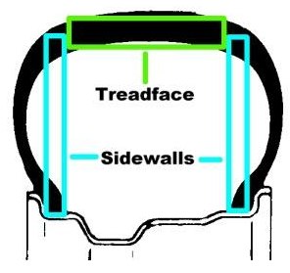

Figure 6: tire model

|  |  |  |  |
| --- | --- | --- | --- |
| **Vehicle segment** | **Minimal wheel size** | **Mass tire**  **[kg]** | **tire inertia**  **[kg*m2]** |
| A | 175/60 R19 | 8.023 | 0.87866 |
| B | 175/60 R19 | 8.023 | 0.87866 |
| C | 245/50 R20 | 13.87993 | 1.8093 |
| D | 245/50 R20 | 13.87993 | 1.8093 |
| E | 265/30 R22 | 14.19 | 2.23815 |
| F | 265/30 R22 | 14.19 | 2.23815 |
| M | 265/30 R22 | 14.19 | 2.23815 |
| J | 265/30 R22 | 14.19 | 2.23815 |
| S | 265/30 R22 | 14.19 | 2.23815 |

Figure 7: tire data

**Wheel:**

The wheels are modelled in two parts, as shown below. The rim itself is treated as a band of constant diameter equal to the rim diameter. The centre section is modelled as a series of slender rods (thin spokes) of length equal to the rim diameter.

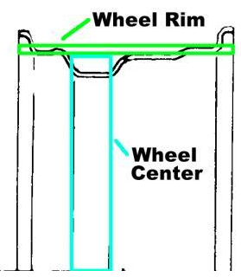

Figure 8: wheel model

|  |  |  |  |  |
| --- | --- | --- | --- | --- |
| **Vehicle segment** | **Minimal wheel size** | **Mass rim**  **[kg]** | **rim inertia**  **[kg*m2]** | **Wheel Inertia [kg*m2]** |
| A | 175/60 R19 | 9.9 | 0.44193 | 1.32059 |
| B | 175/60 R19 | 9.9 | 0.44193 | 1.32059 |
| C | 245/50 R20 | 13.2 | 0.65290 | 2.4622 |
| D | 245/50 R20 | 13.2 | 0.65290 | 2.4622 |
| E | 265/30 R22 | 19.5 | 1.16705 | 3.4052 |
| F | 265/30 R22 | 19.5 | 1.16705 | 3.4052 |
| M | 265/30 R22 | 19.5 | 1.16705 | 3.4052 |
| J | 265/30 R22 | 19.5 | 1.16705 | 3.4052 |
| S | 265/30 R22 | 19.5 | 1.16705 | 3.4052 |

Figure 9: wheel data

# Max Motor Speed

## Definition

Max motor speed is strongly dependent on the following inputs. Maximum vehicle speed defines the maximum motor speed. The vehicle speed will be calculated via tire size and gearbox ratio towards motor speed.

$${mot_spd}_{max}[\frac{U}{min}]={veh_spd}_{max}\left[\frac{km}{h}\right]*\frac{1000*gear_ratio[-]}{60*60*{wheel_circumference}_{min}[m]}$$

## Assumptions

Maximum vehicle speed is dependent on the vehicle type. With size of the vehicle the requested max speed is also increasing.

In general the market shows that also the tire size is changing to bigger diameter. Here some assumptions have to be made, because there is no clear direction of the tire size. Basically all BEV vehicle developed within an existing OEM building block (VW e-Golf, Nissan Leaf) has the same tire size as the ICE vehicles. All BEV vehicles which are developed on a new platform especially for electric vehicles have higher wheel diameter (BMW i3).

## Tire Diameter Forecast

**Article (1):**

Arne Siemers, OE tire development manager for Continental Tire the Am­ericas, adds, “Rolling resistance will continue to be important and a main focus.”

To meet the fuel economy demands, Siemers believes that we “will probably see thinner tires that are bigger in wheel size.” This potential trend toward taller and narrower tires was expanded on by Martini: “While I think overall tire wheel diameters won’t get much larger for most applications, from a style perspective, I do not see the market moving to smaller wheels. Additionally, we’re seeing a new innovation emerging on specialty vehicles like the i3 and i8 BMW – the Bridgestone ‘Ologic’ concept of tall and narrow tires. Changing the tire’s footprint to long and narrow keeps necessary rubber on the road for performance, with much better overall fuel economy. Plus, it has a stylish high wheel diameter look.”

Bridgestone’s ‘Ologic’ technology capitalizes on the synergies of a large diameter coupled with a narrow tread design. Bridgestone says that the resulting tire delivers significant improvement in aerodynamics and rolling resistance, while still offering outstanding grip in wet weather conditions. Significantly, unlike most large wheel diameter tires, the Eco­pia EP500 Ologic tire is not an ultra-low profile design. It is available in four sizes – 155/70R19 84Q, 175/60­R19 86Q, 155/60R20 80Q and 175/­55R20 85Q.

**Announcements:**

BMW i3 R19

VW I.D. R20 (measured)

VW I.D. Buzz R22

Porsche Mission E Front: R21, Rear: R22

Mercedes EQ R22 (measured)

Figure 10: rim size vs. vehicle class

## Summary

Due to the fact that we do not want to have higher motor rpm as 20’000 we will calculate the gear ratio for the different vehicle classes.

The Figure 11 shows the maximum gear ratio to reach the maximum vehicle speed with a 20’000 rpm motor. Lower gear ratio leads to higher vehicle speeds.

Figure 11: gear ratio compared to max vehicle speed (lower gear ratio = higher vehicle speed)  
HP = high performance

Based on Figure 11 a gear ratio from 13.5 will cover most of the needs. Figure 12 shows the maximum speed possible with 20’000 motor rpm and a gear ratio from 13.5 compared to maximum vehicle speed. To have all Segments covered different gear ratios has to be covered.

Figure 12: possible vehicle speed with gear ratio different gear ratios, Sport = 230km/h  
HP = high performance 250km/h

# Peak Power

## Acceleration 0km/h to 100 km/h

Based on the vehicle data it is possible to calculate the necessary peak torque for a system. This is one of the boundaries for the power curve calculation. Acceleration from 0 to 100km/h is calculated with minimal vehicle weight + 2*75kg at 0% slope and without any wind.

In assumption that the vehicle has a static acceleration between 0 to 100 km/h the necessary force can be calculated as shown below. Static acceleration means that there is no degradation of system functions due to rpm, temperature or power.

$$F_{air}\left[kN\right]=\frac{ϱ_{a}\left[\frac{kg}{m^{3}}\right]*c_{d}*A_{f}\left[m^{2}\right]*v_{veh}^{2}\left[\frac{m}{s}\right]}{2*1000}$$

$$F_{roll}\left[kN\right]=\frac{c_{r}*m\left[kg\right]*g\left[\frac{m}{s^{2}}\right]*\cos\left(∝\left[rad\right]\right)}{1000}$$

$$F_{grade}\left[kN\right]=\frac{m\left[kg\right]*g\left[\frac{m}{s^{2}}\right]*\sin\left(∝\left[rad\right]\right)}{1000}$$

$$∝\left[rad\right]=\tan^{-1}{(\frac{slope \left[\%\right]}{100})}$$

$$F_{traction}\left[kN\right]=\frac{m\left[kg\right]*a \left[\frac{m}{s^{2}}\right]}{1000}$$

$$F_{total}\left[kN\right]=F_{air}+F_{roll}+F_{grade}+F_{traction}$$

For the calculation a vehicle model (for details on the model please check: <https://presta-wiki.prestagroup.com/display/EM/Vehicle+Dynamics>) with the above described boundaries were used. In addition the gearbox and driveshaft efficiency and the inertia of the vehicle and the subsystems were considered.

## Acceleration 0km/h to 200 km/h

For details please check the chapter 9.1.

Some vehicle classes do not reach the 200km/h.

## Baldwin Street in New Zealand (40km/h, 35% slope)

With the same vehicle system the following scenario will be simulated.

35% slope with 40km/h. This is the highest slope on the world. The slope is very short.

Vehicle Weight has maximum weight (Vehicle Weight + Payload).

[http://geo.ebp.ch/gelaendeprofil/?latlngs=[[-45.8479613,170.53261109999994],[-45.8504093,170.53589349999993],]&travelMode=driving](http://geo.ebp.ch/gelaendeprofil/?latlngs=%5b%5b-45.8479613,170.53261109999994%5d,%5b-45.8504093,170.53589349999993%5d,%5d&travelMode=driving)

## Power decrease at high speed

Some vehicles has a decrease of power at high motor revolution. Some cases where checked to get an overview.

### Turbocharged engine

As a basis the Audi A3_8V07 1,4l auf ca. 132/(180) kW/(PS) was used. The power curve is straight at high motor revolution.

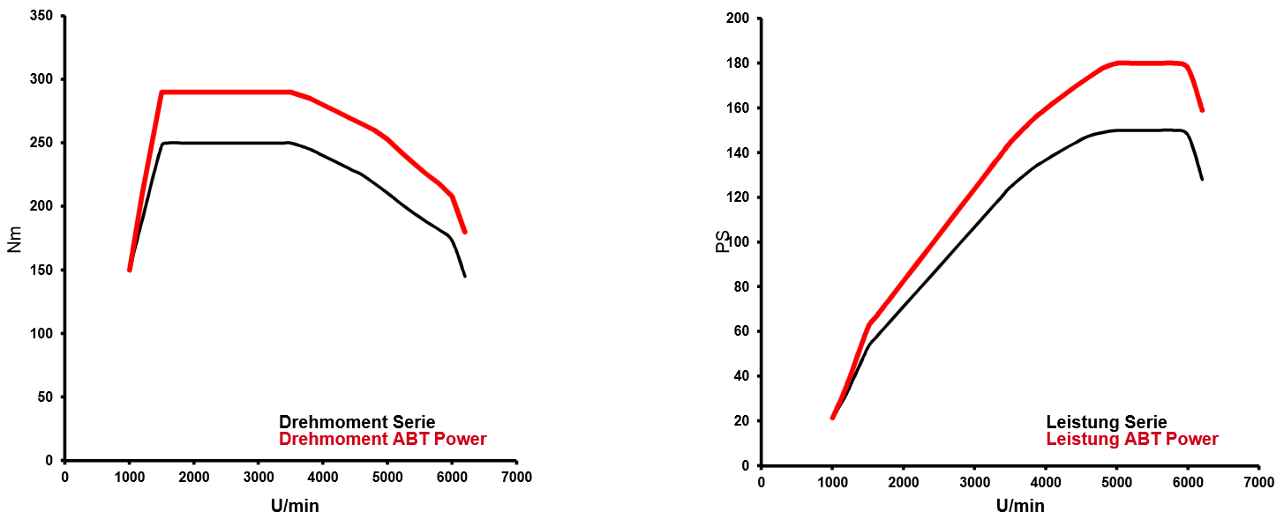

Figure 13: power curve turbocharged engine

### induction engine

As a basis the Audi R8_4S00 Coupe was used. The power curve shows a small reduction of power at high motor revolution. It is approximately 15%.

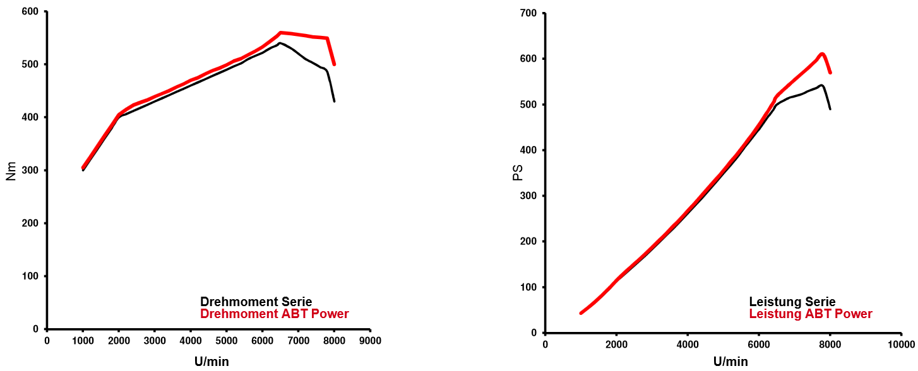

Figure 14: Power Curve induction engine

### BMW i3

BMW i3 doesn’t show any decreasing of torque at higher rpm.

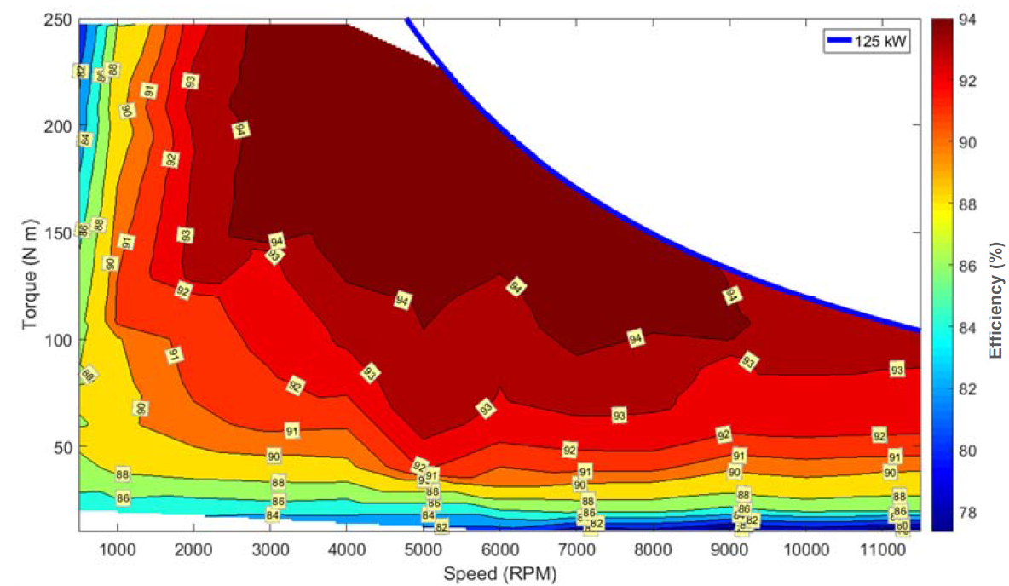

Figure 15: BMW i3 torque curve

### Chevrolet Bolt

The Chevrolet Bolt has a decreasing of approx. 7.5 %.

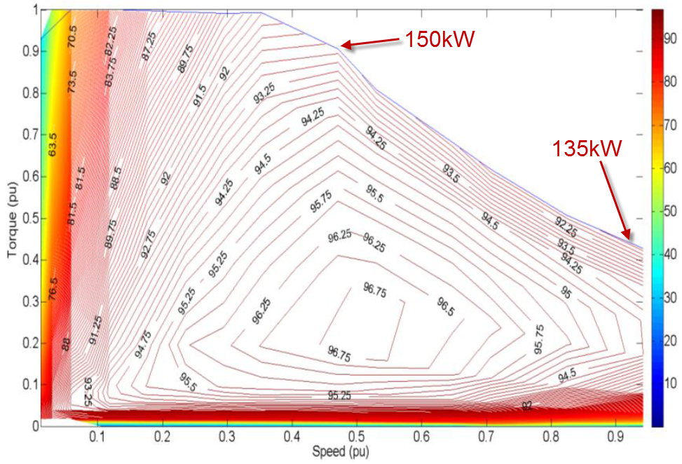

Figure 16: Chevrolet Bolt torque curve

### Chevrolet Spark EV

This figure is from a forum in the internet. It shows the Chevrolet Spark EV axle Torque.

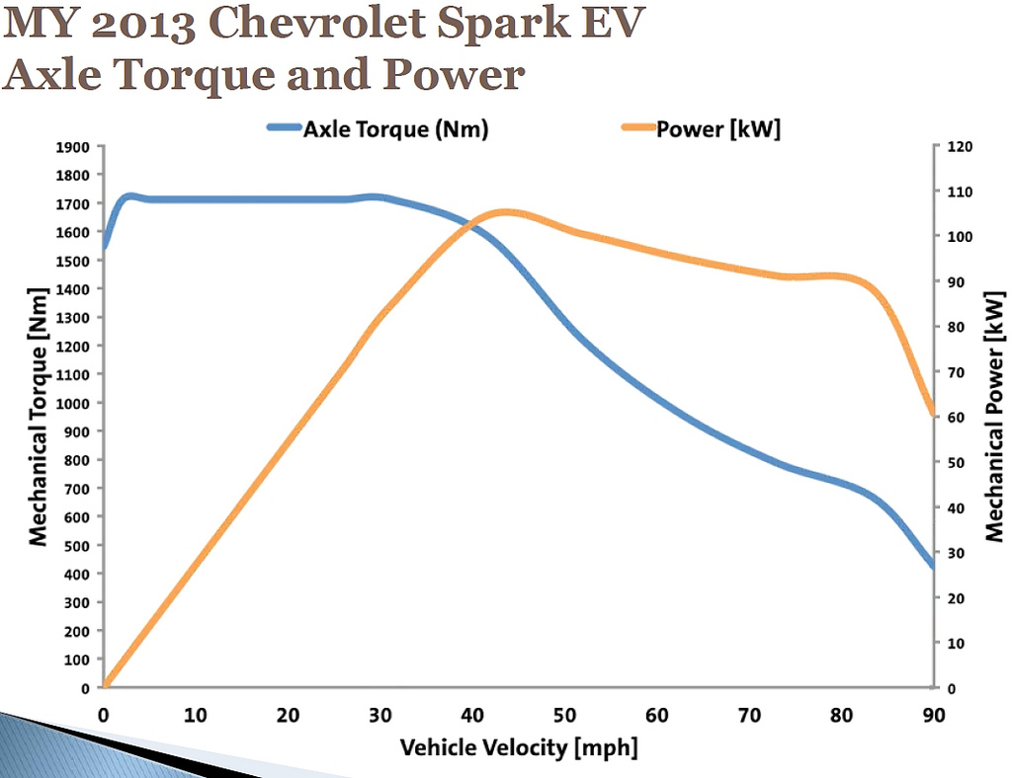

Figure 17: Chevrolet Spark axle torque

### Renault Zoe

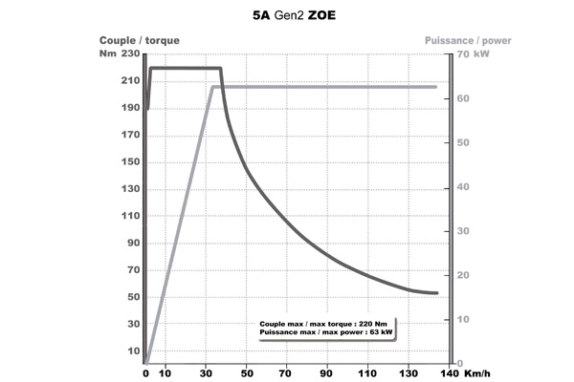

Figure 18: Renault Zoe power curve

### Tesla Model S

Tesla shows a very high power decrease at higher rpms.

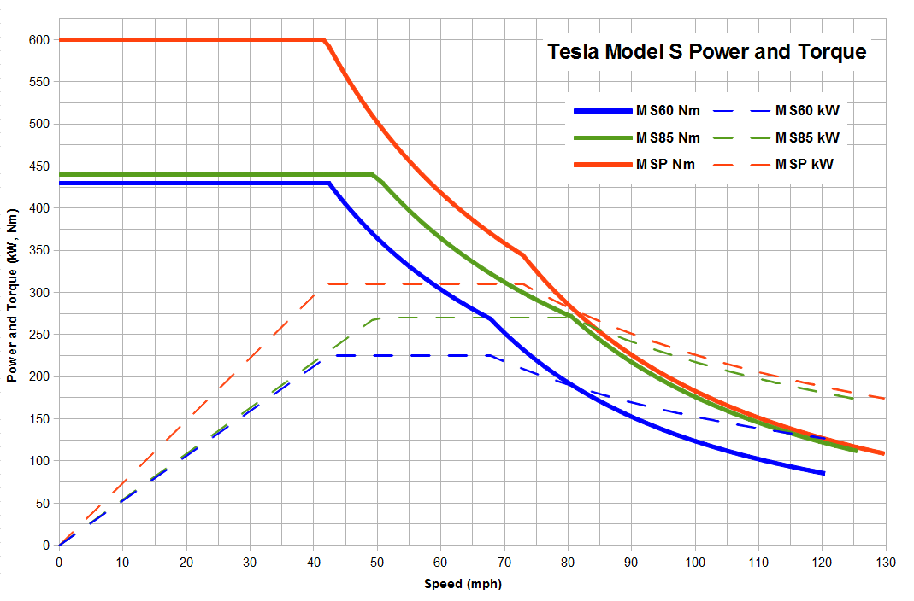

Figure 19: power curve Tesla Model S

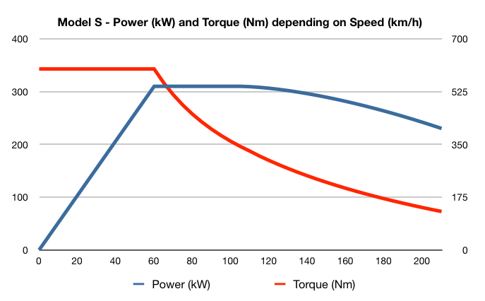

### Summary

For our approach 2 different use cases can be defined.

The motor curve cuts of from 200 km/h and makes a 1/x2 curve.

The other is that it makes a 1/x2 curve but cuts the maximum speed power point.

Both options shown below.

To define a generic motor curve for several translation the highest rpm is chosen for 200km/h based on different gear ratios. Highest rpm is 19023rpm in Segment D with a translation of 13.5.

|  |  |  |  |  |
| --- | --- | --- | --- | --- |
| **i** | **rim size** | **wheel circumference [m]** | **Vehicle segment** | **motor revolution [rpm]** |
| 15.2 | R19 | 2.18 | A,B | ~~23'286~~ |
| 15.2 | R20 | 2.37 | C | ~~21'418~~ |
| 15.2 | R22 | 2.42 | M | ~~20'937~~ |
| 13.5 | R20 | 2.37 | D | 19'023 |
| 13.5 | R22 | 2.42 | E,F,J | 18'595 |
| 12.3 | R20 | 2.37 | D Sport | 17'332 |
| 12.3 | R22 | 2.42 | E Sport,F Sport,J Sport | 16'942 |
| 11.6 | R22 | 2.42 | E HP,F HP,J HP,S | 15'978 |

Table 6: motor revolution at 200km/h

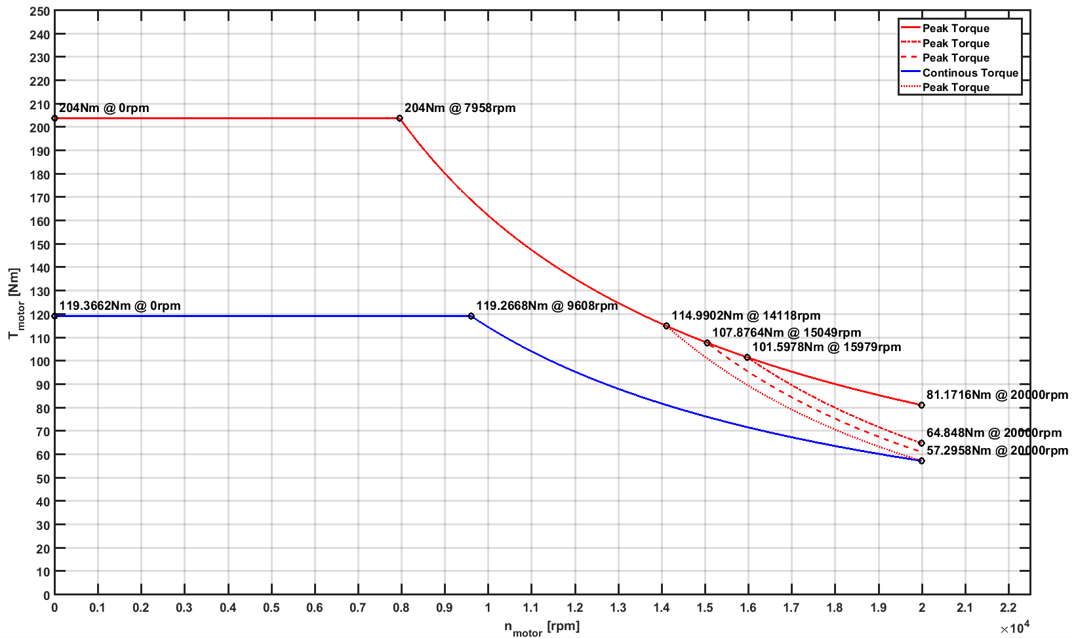

Figure 20: motor curve derivation

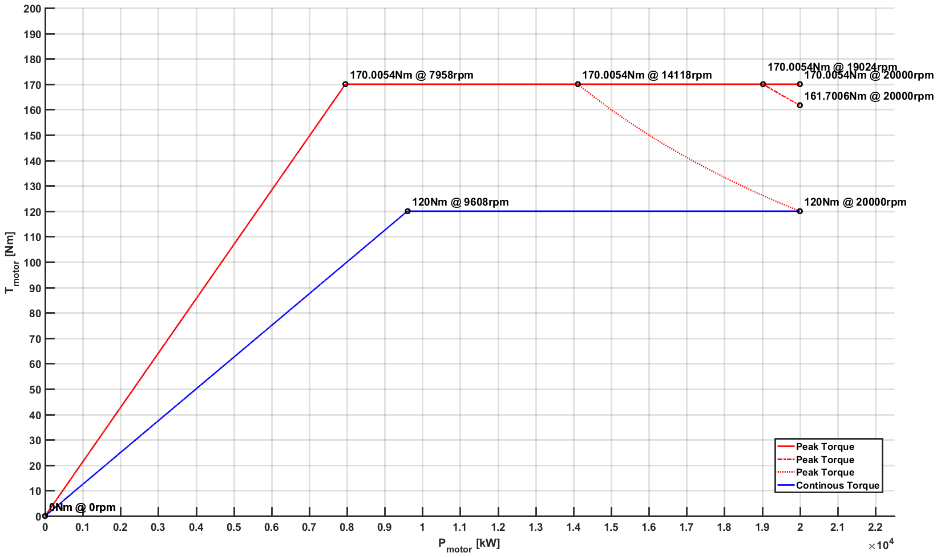

Figure 21: power curve derivation

# Continuous Power

## Mountain Pass (80km/h, 12% slope)

With the same vehicle system the following scenario will be simulated.

80 km/h with 12% slope. This simulates a mountain pass. Vehicle Weight has maximum weight (Vehicle Weight + Payload).

## San Bernadino (80km/h, 12% slope)

San Bernadino is a mountain pass in Switzerland. Vehicle Weight has maximum weight (Vehicle Weight + Payload).

[http://geo.ebp.ch/gelaendeprofil/?latlngs=[[46.1908442,9.006901299999981],[46.8554974,9.507010799999989],]&travelMode=driving](http://geo.ebp.ch/gelaendeprofil/?latlngs=%5b%5b46.1908442,9.006901299999981%5d,%5b46.8554974,9.507010799999989%5d,%5d&travelMode=driving)

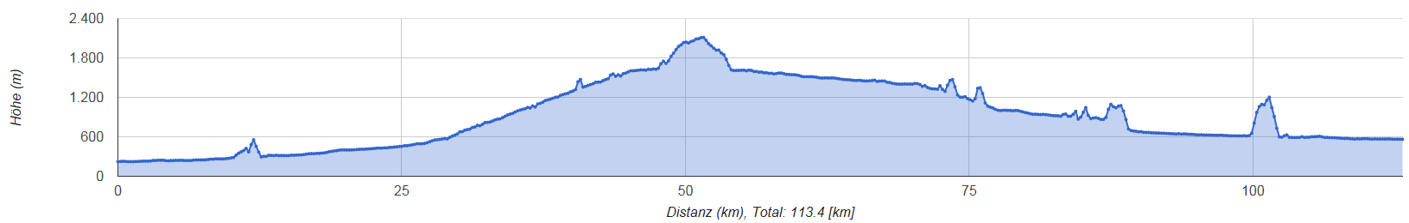

## Kasseler Mountains (100km/h, 8% slope)

Kasseler Mountains are small part of the A7 highway in Germany. It has slopes up to 8% for short distance. Vehicle Weight has maximum weight (Vehicle Weight + Payload).

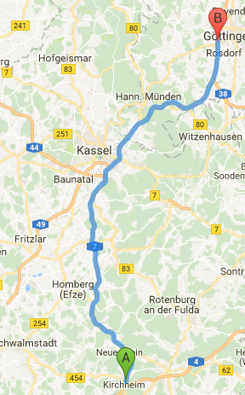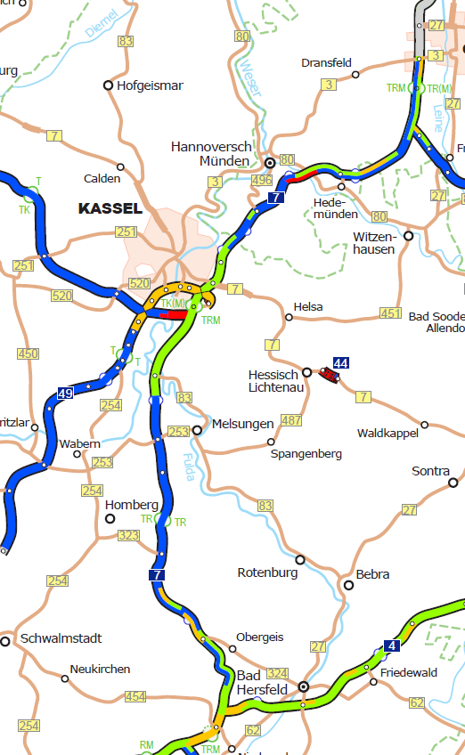

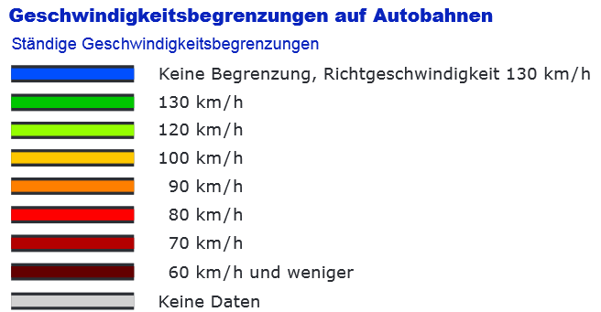

<http://product.itoworld.com/map/124?lon=9.48426&lat=51.27377&zoom=10>

[http://geo.ebp.ch/gelaendeprofil/?latlngs=[[50.8441381,9.583744499999966],[51.5295149,9.879248599999983],]&travelMode=driving](http://geo.ebp.ch/gelaendeprofil/?latlngs=%5b%5b50.8441381,9.583744499999966%5d,%5b51.5295149,9.879248599999983%5d,%5d&travelMode=driving)

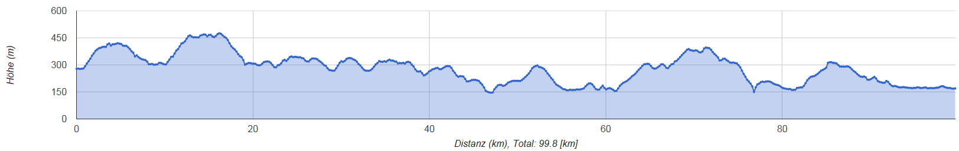

## Highway (140km/h, 4% slope)

Straight driving on highway with 140 km/h at 4% slope. Vehicle Weight has maximum weight (Vehicle Weight + Payload).

## Maximum speed (defined by segment, 0% slope)

Reach the maximum speed for each segment and keep it in straight driving without slope. Vehicle Weight has norm weight (Vehicle Weight + 2*75kg).

# Derived Specification

For a clustering of the systems the following vehicle definitions were made and simulated.

The results can be found here: